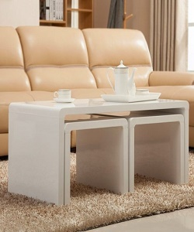

Unique Table

$69.08

Availability: In stock

**Description:**

Unique long rectangle shaped table with 2 square marble stool. A clear striped glossy top provides a place for any items you want to show off, while boxy sled-style base below sports a sleek metallic finish for an on-tred look.this narrow design is perfect look for living room.Assembly is required.